Semester One Final Exam Supplementary Study Guide
The New Nation & Jackson

Directions: Use your book, notes, readings, and any other classroom materials to find definitions or explanations to the following terms and questions. DO NOT GOOGLE these terms to find answers, as it will yield an array of information that may not reflect what you will be asked. Some of the terms are general, so you will need to discern need-to-know info and write complete notes. Not ALL of these terms represent questions on the test, but they do represent the things you will need to know to be successful.

Legacy of the Washington presidency –

Whiskey Rebellion –

Neutrality –

Precedents set –

First Cabinet – list below.
- Secretary of State:
- Secretary of the Treasury:
- Secretary of War:
- Attorney General:

Washington’s Farewell Address (warnings) – describe below drawing from the text.

- Political parties:
- Foreign entanglements:
- Geographical distinctions:

Creation of the first political parties, Hamilton v. Jefferson. Study the chart below and take a look back at their letters to Washington I assigned you.

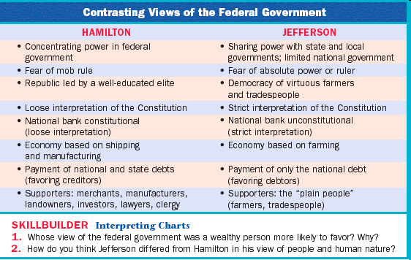

Legacy of the John Adams presidency –

XYZ Affair –

Alien and Sedition Acts –

Election of 1800 –

Judiciary Act of 1801 –

Midnight Judges –

Legacy of the Jefferson presidency –

Louisiana Purchase –
Lewis and Clark –

Embargo Act –

Legacy of the Madison presidency –

War of 1812 –

Treaty of Ghent –

Battle of New Orleans –

Legacy of the Monroe presidency –

Era of Good Feelings –

Monroe Doctrine –

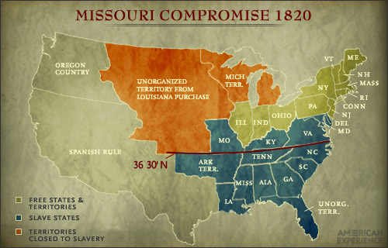
Explain the Missouri Compromise using the map.

Legacy of the John Quincy Adams presidency –

Election of 1824 & “corrupt bargain” –

Legacy of the Marshall Court –

McCulloch v. Maryland –

Marbury v. Madison –

Gibbons v. Ogden –

Andrew Jackson (7th President) – complete the following identifications on AJ.

- Personal Qualities:
- Leadership Style:
- Bank War/Veto:
- Nullification Crisis:
- John C. Calhoun:

- Eaton Affair:
- Spoils System:
- Indian Removal:
- Worcester v. Georgia:
- Legacy of Jackson’s presidency (that’s loaded!!!) –

